Name: Edith Njoki Wangui

Email Address: [edith.wangui@womentechsters.org](mailto:edith.wangui@womentechsters.org)

Practical Activity 2

1. Deployed a windows server 2016 Gen 1 remotely on my machine from azure cloud
2. Resource group Trial 4
3. VMTrial 4

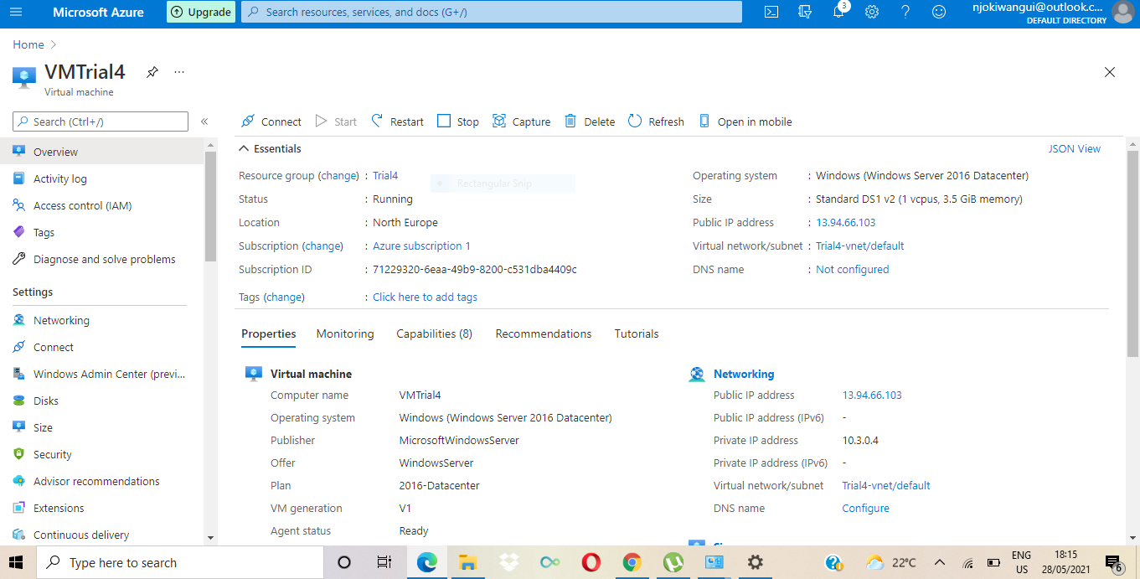

1. After installing the windows feature web server management tools, I confirmed the browser is working.

IP Address: 13.94.66.103

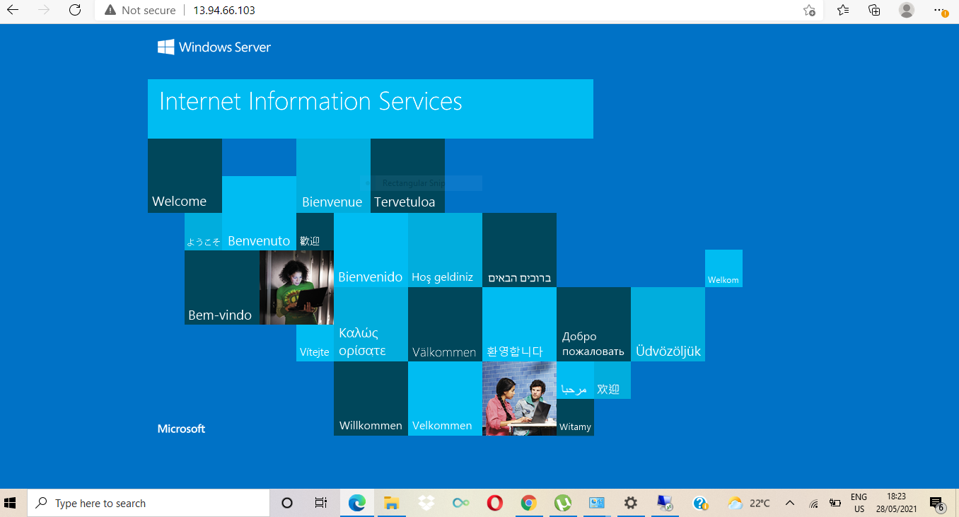

1. I created a site recovery service vault
2. Resource group: trial4_west
3. Vault name: trial4vault

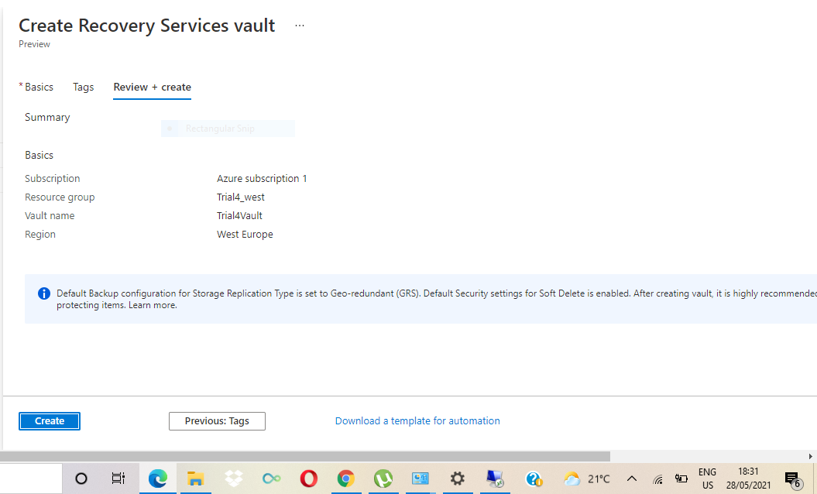

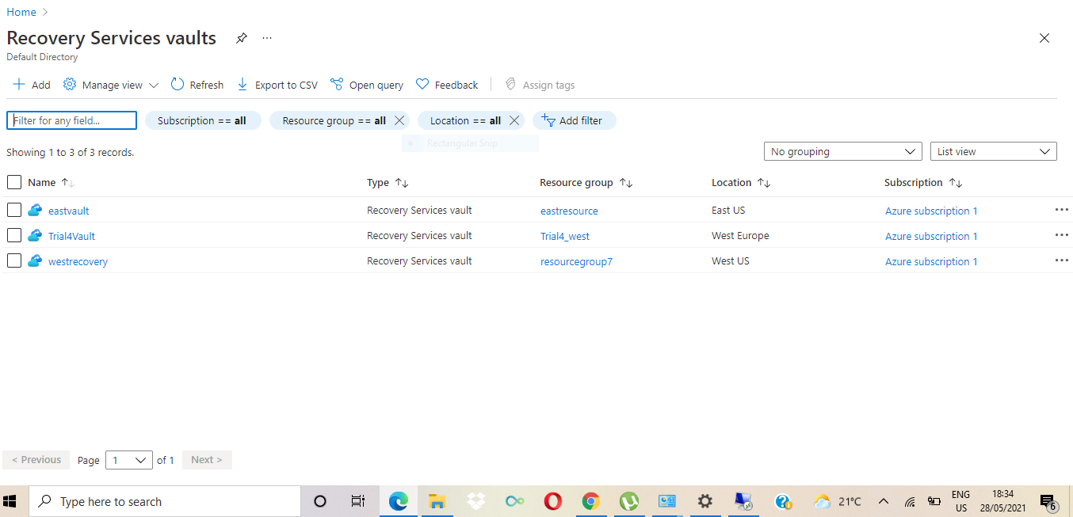

1. Added the windows server to the replicated items

The VMTrial4 was replicated and protected successfully.

At this point I had not performed a test fail over.

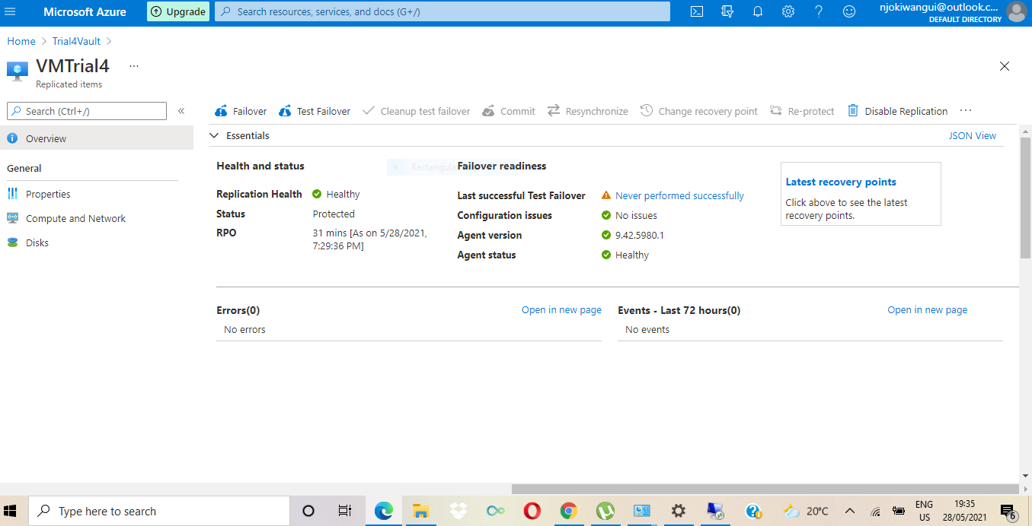

1. I did my test failover and it was a success

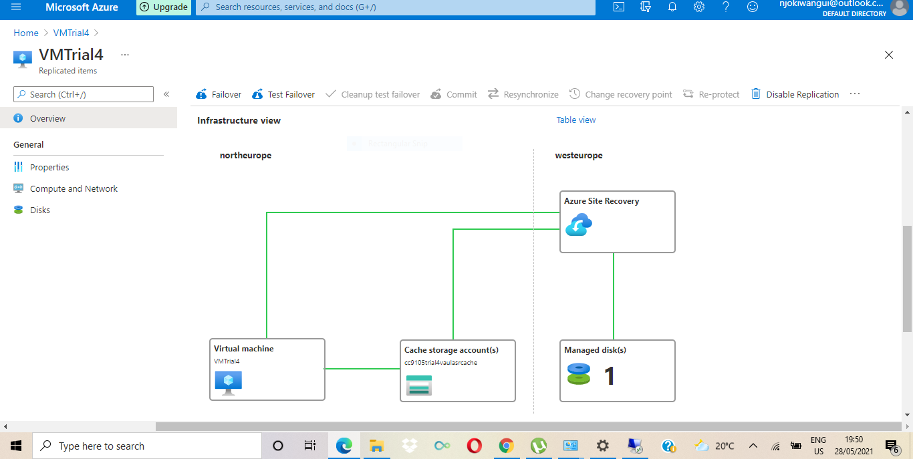

1. Replicated copy of the windows server

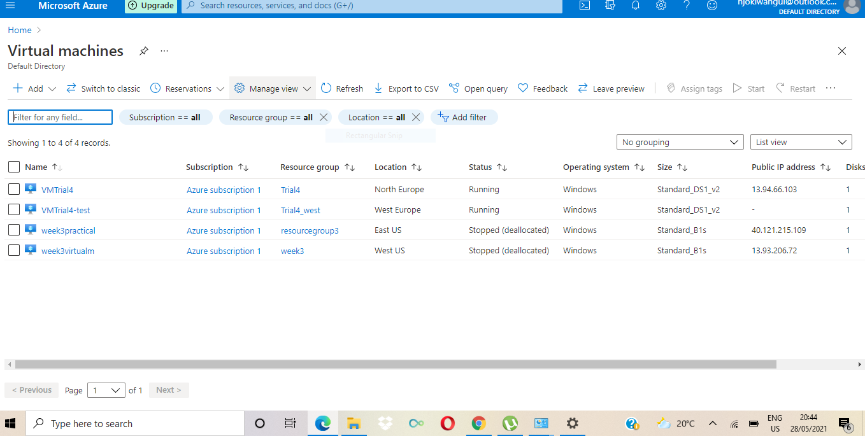

1. No IP address on my replicated vm

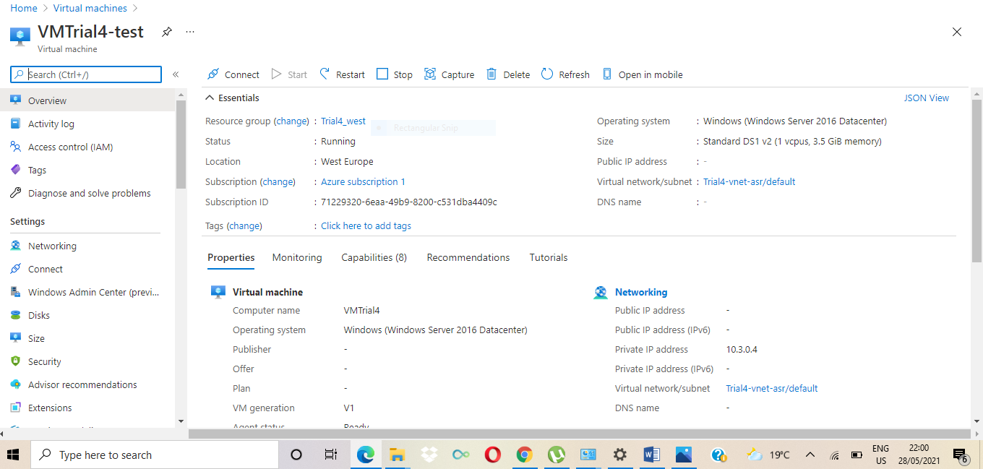

Machine didn’t run

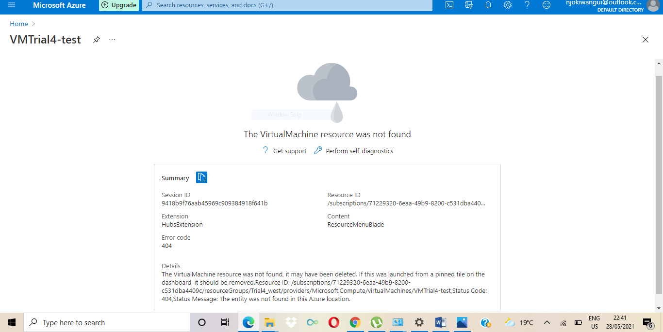

Errors about disk.

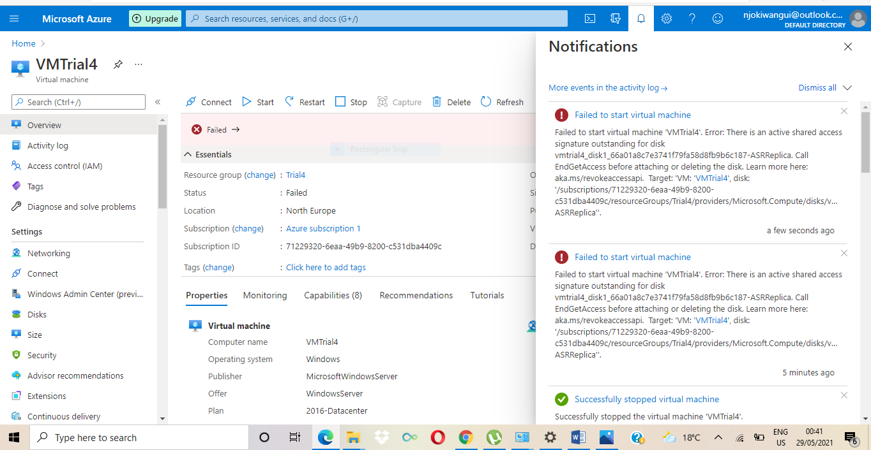

Error causing both virtual machines not to run i.e. main and replicated.

